Cam 01 Academic Reading Test 01

READING PASSAGE 1

You should spend about 20 minutes on Questions 1-15, which are based on Reading Passage 1 below.

A spark, a flint; how fire leapt to life

The control of fire was the first and perhaps greatest of humanity’s steps towards a life-enhancing technology

To early man, fire was a divine gift randomly delivered in the form of lightning, forest fire or burning lava.

Unable to make flame for themselves, the earliest people probably stored fire by keeping slow burning logs alight or by carrying charcoal in pots. How and where man learnt how to produce flame at will is unknown. It was probably a secondary invention, accidentally made during tool-making operations with wood or stone. Studies of primitive societies suggest that the earliest method of making fire was through friction. European peasants would insert a wooden drill in a round hole and rotate it briskly between their palms this process could be speeded up by wrapping a cord around the drill and pulling on each end.

The Ancient Greeks used lenses or concave mirrors to concentrate the sun’s rays and burning glasses were also used by Mexican Aztecs and the Chinese.

Percussion methods of fire-lighting date back to Paleolithic times, when some Stone Age tool-makers discovered that chipping flints produced sparks. The technique became more efficient after the discovery of iron, about 5000 vears ago In Arctic North America, the Eskimos produced a slow-burning spark by striking quartz against iron pyrites, a compound that contains sulphur. The Chinese lit their fires by striking porcelain with bamboo. In Europe, the combination of steel, flint and tinder remained the main method of fire-lighting until the mid 19th century.

Fire-lighting was revolutionised by the discovery of phosphorus, isolated in 1669 by a German alchemist trying to transmute silver into gold. Impressed by the element’s combustibility, several 17th century chemists used it to manufacture fire-lighting devices, but the results were dangerously inflammable. With phosphorus costing the equivalent of several hundred pounds per ounce, the first matches were expensive.

The quest for a practical match really began after 1781 when a group of French chemists came up with the Phosphoric Candle or Ethereal Match, a sealed glass tube containing a twist of paper tipped with phosphorus. When the tube was broken, air rushed in, causing the phosphorus to self- combust. An even more hazardous device, popular in America, was the Instantaneous Light Box — a bottle filled with sulphuric acid into which splints treated with chemicals were dipped.

The first matches resembling those used today were made in 1827 by John Walker, an English pharmacist who borrowed the formula from a military rocket-maker called Congreve. Costing a shilling a box, Congreves were splints coated with sulphur and tipped with potassium chlorate. To light them, the user drew them quickly through folded glass paper.

Walker never patented his invention, and three years later it was copied by a Samuel Jones, who marketed his product as Lucifers. About the same time, a French chemistry student called Charles Sauria produced the first “strike-anywhere” match by substituting white phosphorus for the potassium chlorate in the Walker formula. However, since white phosphorus is a deadly poison, from 1845 match-makers exposed to its fumes succumbed to necrosis, a disease that eats away jaw-bones. It wasn’t until 1906 that the substance was eventually banned.

That was 62 years after a Swedish chemist called Pasch had discovered non-toxic red or amorphous phosphorus, a development exploited commercially by Pasch’s compatriot J E Lundstrom in 1885. Lundstrom’s safety matches were safe because the red phosphorus was non-toxic; it was painted on to the striking surface instead of the match tip, which contained potassium chlorate with a relatively high ignition temperature of 182 degrees centigrade.

America lagged behind Europe in match technology and safety standards. It wasn’t until 1900 that the Diamond Match Company bought a French patent for safety matches — but the formula did not work properly in the different climatic conditions prevailing in America and it was another 11 years before scientists finally adapted the French patent for the US.

The Americans, however, can claim several “firsts” in match technology and marketing. In 1892 the Diamond Match Company pioneered book matches. The innovation didn’t catch on until after 1896, when a brewery had the novel idea of advertising its product in match books. Today book matches are the most widely used type in the US, with 90 percent handed out free by hotels, restaurants and others.

Other American innovations include an anti-afterglow solution to prevent the match from smoldering after it has been blown out; and the waterproof match, which lights after eight hours in water.

Questions 1-8

Complete the summary below.

Choose your answers from the box given below and write them in boxes 1-8 on your answer sheet.

NB There are more words than spaces so you will not use them all you may use any of the words more than once.

EARLY FIRE-LIGHTING METHODS

They tried to 1…………………….burning logs or charcoal 2…………………… that they could create fire themselves. It is suspected that the first man-made flames were produced by 3…………………The very first fire-lighting methods involved the creation of 4……………………by, for example, rapidly 5……………………. a wooden stick in a round hole. The use of 6………………………… or persistent chipping was also widespread in Europe and among other peoples such as the Chinese and 7…………………….. European practice of this method continued until the 1850s 8…………………….the discovery of phosphorus some years earlier.

List of words

Mexicans random rotating despite
preserve realising sunlight lacking
heavenly percussion chance friction
unaware without make heating
eskimos surprised until smoke

Questions 9-15

Look at the following notes that have been made about the matches described in Reading passage.

Decide which type of match (A-H) corresponds with each description and write your answers in the boxes 9-15.

NB There are more matches than descriptions so you will not use them all. You may use any match more than once.

Notes

9 made using a les poisonous type of phosphorus

10 identical to a previous type of match

11 caused a deadly illness

12 first to look like modern matches

13 first matches used for advertising

14 relied on an airtight glass container

15 made with the help of an army design

Type of matches

A the Ethereal Match

B the instantaneous lightbox

C congreves

D lucifers

E the first strike anywhere match

F Lundstrom’s safety match

G book matches

H waterproof matches

READING PASSAGE 2

You should spend about 20 minutes on Questions 16-28, which are based on Reading Passage 2 below.

Zoo conservation programmes

One of London Zoo’s recent advertisements caused me some irritation, so patently did it distort reality. Headlined “Without zoos you might as well tell these animals to get stuffed”, it was bordered with illustrations of several endangered species and went on to extol the myth that without zoos like London Zoo these animals “will almost certainly disappear forever”. With the zoo world’s rather mediocre record on conservation, one might be forgiven for being slightly sceptical about such an advertisement.

Zoos were originally created as places of entertainment, and their suggested involvement with conservation didn’t seriously arise until about 30 years ago, when the Zoological Society of London held the first formal international meeting on the subject. Eight years later, a series of world conferences took place, entitled “The Breeding of Endangered Species”, and from this point onwards conservation became the zoo community’s buzzword. This commitment has now been clearly defined in The World Zoo Conservation Strategy (WZGS, September 1993), which although an important and welcome document does seem to be based on an unrealistic optimism about the nature of the zoo industry.

The WZCS estimates that there are about 10,000 zoos in the world, of which around 1,000 represent a core of quality collections capable of participating in co-ordinated conservation programmes. This is probably the document’s first failing, as I believe that 10,000 is a serious underestimate of the total number of places masquerading as zoological establishments. Of course it is difficult to get accurate data but, to put the issue into perspective, I have found that, in a year of working in Eastern Europe, I discover fresh zoos on almost a weekly basis.

The second flaw in the reasoning of the WZCS document is the naive faith it places in its 1,000 core zoos. One would assume that the calibre of these institutions would have been carefully examined, but it appears that the criterion for inclusion on this select list might merely be that the zoo is a member of a zoo federation or association. This might be a good starting point, working on the premise that members must meet certain standards, but again the facts don’t support the theory. The greatly respected American Association of Zoological Parks and Aquariums (AAZPA) has had extremely dubious members, and in the UK the Federation of Zoological Gardens of Great Britain and Ireland has occasionally had members that have been roundly censured in the national press. These include Robin Hill Adventure Park on the Isle of Wight, which many considered the most notorious collection of animals in the country. This establishment, which for years was protected by the Isle’s local council (which viewed it as a tourist amenity), was finally closed down following a damning report by a veterinary inspector appointed under the terms of the Zoo Licensing Act 1981. As it was always a collection of dubious repute, one is obliged to reflect upon the standards that the Zoo Federation sets when granting membership. The situation is even worse in developing countries where little money is available for redevelopment and it is hard to see a way of incorporating collections into the overall scheme of the WZCS.

Even assuming that the WZCS’s 1,000 core zoos are all of a high standard complete with scientific staff and research facilities, trained and dedicated keepers, accommodation that permits normal or natural behaviour, and a policy of co-operating fully with one another what might be the potential for conservation? Colin Tudge, author of Last Animals at the Zoo (Oxford University Press, 1992), argues that “if the world”s zoos worked together in co-operative breeding programmes, then even without further expansion they could save around 2,000 species of endangered land vertebrates’. This seems an extremely optimistic proposition from a man who must be aware of the failings and weaknesses of the zoo industry the man who, when a member of the council of London Zoo, had to persuade the zoo to devote more of its activities to conservation. Moreover, where are the facts to support such optimism?

Today approximately 16 species might be said to have been “saved” by captive breeding programmes, although a number of these can hardly be looked upon as resounding successes. Beyond that, about a further 20 species are being seriously considered for zoo conservation programmes. Given that the international conference at London Zoo was held 30 years ago, this is pretty slow progress, and a long way off Tudge’s target of 2,000.

Questions 16-22

Do the following statements agree with the views of the writer in Reading Passage 2?

In boxes 16-22 write

YES if the statement agrees with the writer
NO if the statement contradicts the writer
NOT GIVEN if it is impossible to say what the writer thinks about this

16 London Zoo’s advertisements are dishonest.
17 Zoos made an insignificant contribution to conservation up until 30 years ago.
18 The WZCS document is not known in Eastern Europe.
19 Zoos in the WZCS select list were carefully inspected.
20 No one knew how the animals were being treated at Robin Hill Adventure Park.
21 Colin Tudge was dissatisfied with the treatment of animals at London Zoo.
22 The number of successful zoo conservation programme is unsatisfactory.

Questions 23-25

Choose the appropriate letters A-D and write them in boxes 23-25 on your answer sheet.

23 What were the objectives of the WZCS document?
A to improve the calibre of zoos world-wide
B to identify zoos suitable for conservation practice
C to provide funds for zoos in underdeveloped countries
D to list the endangered species of the world

24 Why does the writer refer to Robin Hill Adventure Park?
A to support the Isle of Wight local council
B to criticise the 1981 Zoo Licensing Act
C to illustrate a weakness in the WZCS document
D to exemplify the standards in AAZPA zoos

25 What word best describes the writer’s response to Colin Tudges’ prediction on captive breeding programmes?
A disbelieving
B impartial
C prejudiced
D accepting

Questions 26-28

The writer mentions a number of factors which lead him to doubt the value of the WZCS document.

Which THREE of the following factors are mentioned?

Write your answers (A-F) in boxes 26-28 on your answer sheet.

List of Factors

A the number of unregistered zoos in the world
B the lack of money in developing countries
C the actions of the Isle of Wight local council
D the failure of the WZCS to examine the standards of the “core zoos”
E the unrealistic aim of the WZCS in view of the number of species “saved” to date
F the policies of WZCS zoo managers

READING PASSAGE 3

You should spend about 20 minutes on Questions 29-40, which are based on Reading Passage 3 below.

Architecture - Reaching for the Sky

Architecture is the art and science of designing buildings and structures. A building reflects the scientific and technological achievements of the age as well as the ideas and aspirations of the designer and client. The appearance of individual buildings, however, is often controversial.

The use of an architectural style cannot be said to start or finish on a specific date. Neither is it possible to say exactly what characterises a particular movement. But the origins of what is now generally known as modern architecture can be traced back to the social and technological changes of the 18th and 19th centuries.

Instead of using timber, stone and traditional building techniques, architects began to explore ways of creating buildings by using the latest technology and materials such as steel, glass and concrete strengthened steel bars, known as reinforced concrete. Technological advances also helped bring about the decline of rural industries and an increase in urban populations as people moved to the towns to work in the new factories. Such rapid and uncontrolled growth helped to turn parts of cities into slums.

By the 1920s architects throughout Europe were reacting against the conditions created by industrialisation. A new style of architecture emerged to reflect more idealistic notions for the future. It was made possible by new materials and construction techniques and was known as Modernism.

By the 1930s many buildings emerging from this movement were designed in the International Style. This was largely characterised by the bold use of new materials and simple, geometric forms, often with white walls supported by stilt¬like pillars. These were stripped of unnecessary decoration that would detract from their primary purpose — to be used or lived in.

Walter Gropius, Charles Jeanneret (better known as Le Corbusier) and Ludwig Mies van der Rohe were among the most influential of the many architects who contributed to the development of Modernism in the first half of the century. But the economic depression of the 1930s and the second world war (1939-45) prevented their ideas from being widely realised until the economic conditions improved and war-torn cities had to be rebuilt. By the 1950s, the International Style had developed into a universal approach to building, which standardised the appearance of new buildings in cities across the world.

Unfortunately, this Modernist interest in geometric simplicity and function became exploited for profit. The rediscovery of quick-and-easy-to-handle reinforced concrete and an improved ability to prefabricate building sections meant that builders could meet the budgets of commissioning authorities and handle a renewed demand for development quickly and cheaply. But this led to many badly designed buildings, which discredited the original aims of Modernism.

Influenced by Le Corbusier’s ideas on town planning, every large British city built multi-storey housing estates in the 1960s. Mass- produced, low-cost high-rises seemed to offer a solution to the problem of housing a growing inner-city population. But far from meeting human needs, the new estates often proved to be windswept deserts lacking essential social facilities and services. Many of these buildings were poorly designed and constructed and have since been demolished.

By the 1970s, a new respect for the place of buildings within the existing townscape arose. Preserving historic buildings or keeping only their facades (or fronts) grew common.

Architects also began to make more use of building styles and materials that were traditional to the area. The architectural style usually referred to as High Tech was also emerging. It celebrated scientific and engineering achievements by openly parading the sophisticated techniques used in construction. Such buildings are commonly made of metal and glass; examples are Stansted airport and the Lloyd’s building in London.

Disillusionment at the failure of many of the poor imitations of Modernist architecture led to interest in various styles and ideas from the past and present. By the 1980s the coexistence of different styles of architecture in the same building became known as Post Modern. Other architects looked back to the classical tradition. The trend in architecture now favours smaller scale building design that reflects a growing public awareness of environmental issues such as energy efficiency. Like the Modernists, people today recognise that a well designed environment improves the quality of life but is not necessarily achieved by adopting one well defined style of architecture.

Twentieth century architecture will mainly be remembered for its tall buildings. They have been made possible by the development of light steel frames and safe passenger lifts. They originated in the US over a century ago to help meet the demand for more economical use of land. As construction techniques improved, the skyscraper became a reality.

Questions 29-35

Complete the table below using information from Reading Passage 3.

Write NO MORE THAN THREE WORDS for each answer.

Write your answers in boxes 29-35 on your answer sheet.

Period | Style of Period | Building Materials | Characteristics
Before 8th century | example: traditional | 29…………………..
1920s | introduction of 30……………….. | steel, glass and concrete | exploration of latest technology
1930s - 1950s | 31……………………. |  | geometric forms
1960s | decline of Modernism | pre-fabricated sections | 32……………………
1970s | end of Modernist era | traditional materials | 33…………………of historic buildings
1970s | beginning of 34………………era | metal and glass | sophisticated techniques paraded
1980s | Post-Modernism |  | 35…………………

Questions 36-40

Reading Passage 3 describes a number of cause and effect relationships.

Match each Cause (36-40) in List A, with its Effect (A-H) in List B.

Write your answers (A-H) in boxes 36 40 on your answer sheet.

NB There are more effects in List B than you will need, so you will not use all of them. You may use any effect more than once if you wish.

List A Causes | List B Effects
36 A rapid movement of people from rural areas to cities is triggered by technological advance  37 Buildings become simple and functional  38 An economic depression and the second world war hit Europe  39 Multi-storey housing estates are built according to contemporary ideas on town planning  40 Less land must be used for building A The quality of life is improved | A The quality of life is improved  B Architecture reflects the age  C A number of these have been knocked down  D Light steel frames and lifts are developed  E Historical buildings are preserved  F All decoration is removed  G Parts of cities become slums  H Modernist ideas cannot be put into practice until the second half of the 20th century

=================================================================

Cambridge 01 Academic Reading Test 01

Answers

1. preserve
2. unaware
3. chance
4. friction
5. rotating
6. percussion
7. eskimos
8. despite
9. F
10. D
11. E
12. C
13. G
14. A
15. C
16. yes
17. yes
18. not given
19. no
20. no
21. not given
22. yes
23. B
24. C
25. A
26. A
27. D
28. E
29. timber and stone
30. modernism
31. international style
32. badly designed building
33. preservation
34. high-tech
35. different styles together
36. G
37. F
38. H
39. C
40. D

=================================================================

Cam 01 Academic Reading Test 02

READING PASSAGE 1

You should spend about 20 minutes on Questions 1-13, which are based on Reading Passage 1 below.

Right and left-handedness in humans

Why do humans, virtually alone among all animal species, display a distinct left or right-handedness? Not even our closest relatives among the apes possess such decided lateral asymmetry, as psychologists call it. Yet about 90 per cent of every human population that has ever lived appears to have been right-handed. Professor Bryan Turner at Deakin University has studied the research literature on left-handedness and found that handedness goes with sidedness. So nine out of ten people are right-handed and eight are right-footed. He noted that this distinctive asymmetry in the human population is itself systematic. “Humans think in categories: black and white, up and down, left and right. It’s a system of signs that enables us to categorise phenomena that are essentially ambiguous.’

Research has shown that there is a genetic or inherited element to handedness. But while left-handedness tends to run in families, neither left nor right handers will automatically produce off-spring with the same handedness; in fact about 6 per cent of children with two right-handed parents will be left-handed. However, among two left-handed parents, perhaps 40 per cent of the children will also be left-handed. With one right and one left-handed parent, 15 to 20 per cent of the offspring will be left- handed. Even among identical twins who have exactly the same genes, one in six pairs will differ in their handedness.

What then makes people left-handed if it is not simply genetic? Other factors must be at work and researchers have turned to the brain for clues. In the 1860s the French surgeon and anthropologist, Dr Paul Broca, made the remarkable finding that patients who had lost their powers of speech as a result of a stroke (a blood clot in the brain) had paralysis of the right half of their body. He noted that since the left hemisphere of the brain controls the right half of the body, and vice versa, the brain damage must have been in the brain’s left hemisphere. Psychologists now believe that among right-handed people, probably 95 per cent have their language centre in the left hemisphere, while 5 per cent have right-side language. Left-handers, however, do not show the reverse pattern but instead a majority also have their language in the left hemisphere. Some 30 per cent have right hemisphere language.

Dr Brinkman, a brain researcher at the Australian National University in Canberra, has suggested that evolution of speech went with right-handed preference. According to Brinkman, as the brain evolved, one side became specialised for fine control of movement (necessary for producing speech) and along with this evolution came right- hand preference. According to Brinkman, most left-handers have left hemisphere dominance but also some capacity in the right hemisphere. She has observed that if a left-handed person is brain-damaged in the left hemisphere, the recovery of speech is quite often better and this is explained by the fact that left-handers have a more bilateral speech function.

In her studies of macaque monkeys, Brinkman has noticed that primates (monkeys) seem to learn a hand preference from their mother in the first year of life but this could be one hand or the other. In humans, however, the specialisation in (unction of the two hemispheres results in anatomical differences: areas that are involved with the production of speech are usually larger on the left side than on the right. Since monkeys have not acquired the art of speech, one would not expect to see such a variation but Brinkman claims to have discovered a trend in monkeys towards the asymmetry that is evident in the human brain.

Two American researchers, Geschwind and Galaburda, studied the brains of human embryos and discovered that the left-right asymmetry exists before birth. But as the brain develops, a number of things can affect it. Every brain is initially female in its organisation and it only becomes a male brain when the male foetus begins to secrete hormones. Geschwind and Galaburda knew that different parts of the brain mature at different rates; the right hemisphere develops first, then the left. Moreover, a girl’s brain develops somewhat faster than that of a boy. So, if something happens to the brain’s development during pregnancy, it is more likely to be affected in a male and the hemisphere more likely to be involved is the left. The brain may become less lateralised and this in turn could result in left-handedness and the development of certain superior skills that have their origins in the left hemisphere such as logic, rationality and abstraction. It should be no surprise then that among mathematicians and architects, left-handers tend to be more common and there are more left-handed males than females.

The results of this research may be some consolation to left-handers who have for centuries lived in a world designed to suit right-handed people. However, what is alarming, according to Mr. Charles Moore, a writer and journalist, is the way the word “right” reinforces its own virtue. Subliminally he says, language tells people to think that anything on the right can be trusted while anything on the left is dangerous or even sinister. We speak of left-handed compliments and according to Moore, “it is no coincidence that left-handed children, forced to use their right hand, often develop a stammer as they are robbed of their freedom of speech”. However, as more research is undertaken on the causes of left-handedness, attitudes towards left-handed people are gradually changing for the better. Indeed when the champion tennis player Ivan Lendl was asked what the single thing was that he would choose in order to improve his game, he said he would like to become a left-hander.

Questions 1-7

Use the information in the text to match the people (listed A-E) with the opinions (listed 1-7) below.

Write the appropriate letter (A-E) in boxes 1-7 on your answer sheet.

Some people match more than one opinion.

A Dr Broca
B Dr Brinkman
C Geschwind and Galaburda
D Charles Moore
E Professor Turner

1 Human beings started to show a preference for right-handedness when they first developed language.
2 Society is prejudiced against left-handed people.
3 Boys are more likely to be left-handed.
4 After a stroke, left-handed people recover their speech more quickly than right-handed people.
5 People who suffer strokes on the left side of the brain usually lose their power of speech.
6 The two sides of the brain develop different functions before birth.
7 Asymmetry is a common feature of the human body.

Questions 8-10

Using the information in the passage, complete the table below.

Write your answers in boxes 8-10 on your answer sheet.

 | Percentage of children left-handed
One parent left handed  One parent right handed | 8 ……………..
Both parents left handed | 9 …………….
Both parents right handed | 10 …………….

Questions 11-12

Choose the appropriate letters A-D and write them in boxes 11 and 12 on your answer sheet.

11 A study of monkeys has shown that
A monkeys are not usually right-handed
B monkeys display a capacity for speech
C monkey brains are smaller than human brains
D monkey brains are asymmetric

12 According to the writer, left-handed people
A will often develop a stammer
B have undergone hardship for years
C are untrustworthy
D are good tennis players

READING PASSAGE 2

You should spend about 20 minutes on Questions 13-27, which are based on Reading Passage 2 below.

MIGRATORY BEEKEEPING
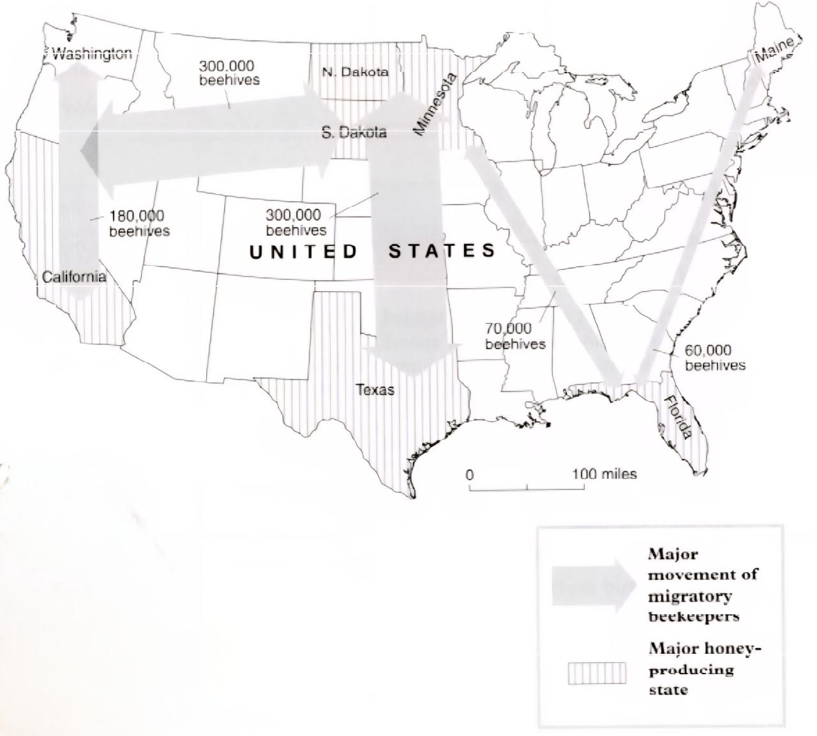
Taking Wing

To eke out a full-time living from their honeybees, about half the nation’s 2,000 commercial beekeepers pull up stakes each spring, migrating north to find more flowers for their bees. Besides turning floral nectar into honey, these hardworking insects also pollinate crops for farmers - for a fee. As autumn approaches, the beekeepers pack up their hives and go south, scrambling for pollination contracts in hot spots like California’s fertile Central Valley.

Of the 2,000 commercial beekeepers in the United States about half migrate This pays off in two ways moving north in the summer and south in the winter lets bees work a longer blooming season, making more honey — and money — for their keepers. Second, beekeepers can carry their hives to farmers who need bees to pollinate their crops. Every spring a migratory beekeeper in California may move up to 160 million bees to flowering fields in Minnesota and every winter his family may haul the hives back to California, where farmers will rent the bees to pollinate almond and cherry trees.

Migratory beekeeping is nothing new. The ancient Egyptians moved clay hives, probably on rafts, down the Nile to follow the bloom and nectar flow as it moved toward Cairo. In the 1880s North American beekeepers experimented with the same idea, moving bees on barges along the Mississippi and on waterways in Florida, but their lighter, wooden hives kept falling into the water. Other keepers tried the railroad and horse- drawn wagons, but that didn’t prove practical. Not until the 1920s when cars and trucks became affordable and roads improved, did migratory beekeeping begin to catch on.

For the Californian beekeeper, the pollination season begins in February. At this time, the beehives are in particular demand by farmers who have almond groves; they need two hives an acre. For the three-week long bloom, beekeepers can hire out their hives for $32 each. It’s a bonanza for the bees too. Most people consider almond honey too bitter to eat so the bees get to keep it for themselves.

By early March it is time to move the bees. It can take up to seven nights to pack the 4,000 or so hives that a beekeeper may own. These are not moved in the middle of the day because too many of the bees would end up homeless. But at night, the hives are stacked onto wooden pallets, back-to-back in sets of four, and lifted onto a truck. It is not necessary to wear gloves or a beekeeper’s veil because the hives are not being opened and the bees should remain relatively quiet. Just in case some are still lively, bees can be pacified with a few puffs of smoke blown into each hive’s narrow entrance.

In their new location, the beekeeper will pay the farmer to allow his bees to feed in such places as orange groves. The honey produced here is fragrant and sweet and can be sold by the beekeepers. To encourage the bees to produce as much honey as possible during this period, the beekeepers open the hives and stack extra boxes called supers on top. These temporary hive extensions contain frames of empty comb for the bees to fill with honey. In the brood chamber below, the bees will stash honey to eat later. To prevent the queen from crawling up to the top and laying eggs, a screen can be inserted between the brood chamber and the supers. Three weeks later the honey can be gathered.

Foul smelling chemicals are often used to irritate the bees and drive them down into the hive’s bottom boxes, leaving the honey- filled supers more or less bee free. These can then be pulled off the hive. They are heavy with honey and may weigh up to 90 pounds each. The supers are taken to a warehouse. In the extracting room, the frames are tilted out and lowered into an “uncapper” where rotating blades shave away the wax that covers each cell. The uncapped frames are put in a carousel that sits on the bottom of a large stainless steel drum. The carousel is filled to capacity with 72 frames. A switch is flipped and the frames begin to whirl at 300 revolutions per minute; centrifugal force throws the honey out of the combs. Finally the honey is poured into barrels for shipment.

After this, approximately a quarter of the hives weakened by disease, mites, or an ageing or dead queen, will have to be replaced. To create new colonies, a healthy double hive, teeming with bees, can be separated into two boxes. One half will hold the queen and a young, already mated queen can be put in the other half, to make two hives from one. By the time the flowers bloom, the new queens will be laying eggs, filling each hive with young worker bees. The beekeeper’s family will then migrate with them to their summer location.

Questions 13-19

The steps below outline the movements of the migratory beekeepers as described in the passage.

Compete the steps.

Choose your answers from the options given below.

Beekeeper Movements

1. In March, beekeepers 13………………..for migration at night when the hives are 14……………and the bees are generally tranquil. A little 15……………can ensure that this is the case.

2. They transport their hives to orange groves where farmers 16……………beekeepers for placing them on their land. Here the bees make honey.

3. After three weeks, the supers can be taken to a warehouse where 17……………are used to remove the wax and extract the honey from the 18……………….

4. After the honey collection, the old hives are rejected. Good double hives are 19…………….and re-queened and the beekeeper transports to their summer base.

List of words

Smoke Barrels Set-off Pollinate Combs Full

Chemicals Protection Light Machines Screen Empty

Pay Charge Split Supers Prepare Queens

Questions 20-23

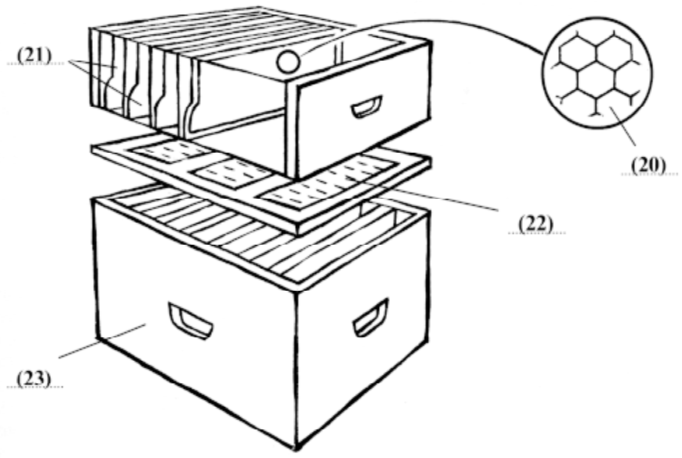

20
21
22
23

Questions 24-27

Do the following statements agree with the information given in Reading Passage 2?

In boxes 24-27 write.

YES if the statement agrees with the information given
NO if the statement contradicts the information given
NOT GIVEN if there is no information about this

24 The Egyptians keep bees on the banks of the Nile.
25 First attempts at migratory beekeeping in America were unsuccessful.
26 Bees keep honey for themselves in the bottom of the hive.
27 The honey is spun to make it liquid.

READING PASSAGE 3

You should spend about 20 minutes on Questions 28-40, which are based on Reading Passage 3 below.

TOURISM

A
Tourism, holidaymaking and travel are these days more significant social phenomena than most commentators have considered. On the face of it there could not be a more trivial subject for a book and indeed since social scientists have had considerable difficulty explaining weightier topics such as work or politics it might be thought that they would have great difficulties in accounting for more trivial phenomena such as holidaymaking. However there are interesting parallels with the study of deviance. This involves the investigation of bizarre and idiosyncratic social practices which happen to be defined as deviant in some societies but not necessarily in others. The assumption is that the investigation of deviance can reveal interesting and significant aspects of normal societies It could be said that a similar analysis can be applied to tourism.

B
Tourism is a leisure activity which presupposes its opposite namely regulated and organised work. It is one manifestation of how work and leisure are organised as separate and regulated spheres of social practice in modern societies Indeed acting as a tourist is one of the defining characteristics of being modern’ and the popular concept of tourism is that it is organised within particular places and occurs for regularised periods of time. Tourist relationships arise from a movement of people to and their stay in various destinations. This necessarily involves some movement that is the journey and a period of stay in a new place or places. The journey and the stay are by definition outside the normal places of residence and work and are of a short term and temporary nature and there is a clear intention to return “home within a relatively short period of time.

C
A substantial proportion of the population of modern societies engages in such tourist practices new socialised forms of provision have developed in order to cope with the mass character of the gazes of tourists as opposed to the individual character of travel. Places are chosen to be visited and be gazed upon because there is an anticipation especially through daydreaming and fantasy of intense pleasures, either on a different scale or involving different senses from those customarily encountered. Such anticipation is constructed and sustained through a variety of non-tourist practices such as films TV literature, magazines records and videos which construct and reinforce this daydreaming.

D
Tourists tend to visit features of landscape and townscape which separate them off from everyday experience. Such aspects are viewed because they are taken to be in some sense out of the ordinary. The viewing of these tourist sights often involves different forms of social patterning with a much greater sensitivity to visual elements of landscape or townscape than is normally found in everyday life. People linger over these sights in a way that they would not normally do in their home environment and the vision is objectified or captured through photographs postcards films and so on which enable the memory to be endlessly reproduced and recaptured.

E
One of the earliest dissertations on the subject of tourism is Boorstins analysis of the pseudo event (1964) where he argues that contemporary Americans cannot experience reality’ directly but thrive on “pseudo events”. Isolated from the host environment and the local people the mass tourist travels in guided groups and finds pleasure in inauthentic contrived attractions gullibly enjoying the pseudo events and disregarding the real world outside. Over time the images generated of different tourist sights come to constitute a closed self-perpetuating system of illusions which provide the tourist with the basis for selecting and evaluating potential places to visit. Such visits are made says Boorstin, within the “environmental bubble of the familiar American style hotel which insulates the tourist from the strangeness of the host environment.

F
To service the burgeoning tourist industry, an array of professionals has developed who attempt to reproduce ever-new objects for the tourist to look at. These objects or places are located in a complex and changing hierarchy. This depends upon the interplay between, on the one hand, competition between interests involved in the provision of such objects and, on the other hand changing class, gender, and generational distinctions of taste within the potential population of visitors. It has been said that to be a tourist is one of the characteristics of the “modern experience. Not to go away is like not possessing a car or a nice house. Travel is a marker of status in modern societies and is also thought to be necessary for good health. The role of the professional, therefore, is to cater for the needs and tastes of the tourists in accordance with their class and overall expectations.

Questions 28-32

Raiding Passage 3 has 6 paragraphs (A-F).

Choose the most suitable heading for each paragraph from the list of headings below.

Write the appropriate numbers (i-ix) in boxes 28 32 on your answer sheet Paragraph D has been done for you as an example.

NB There are more headings than paragraphs so you will not use all of them. You may use any heading more than once.

List of Headings

I The politics of tourism
ii The cost of tourism
iii Justifying the study of tourism
iv Tourism contrasted with travel
v The essence of modern tourism
vi Tourism versus leisure
vii The artificiality of modern tourism
viii The role of modern tour guides
ix Creating an alternative to the everyday experience

28 Paragraph A
29 Paragraph B
30 Paragraph C
31 Paragraph E
32 Paragraph F

Questions 33-37

Do the following statements agree with the views of the writer in Reading Passage 3?

In boxes 33-37, write

YES if the statement agrees with the writer
NO if the statement contradicts the writer
NOT GIVEN if it is impossible to say what the writer thinks about this

33 Tourism is a trivial subject.
34 An analysis of deviance can act as a model for the analysis of tourism.
35 Tourists usually choose to travel overseas.
36 Tourists focus more on places they visit than those at home.
37 Tour operators try to cheat tourists.

Questions 38-41

Chose one phrase (A-H) from the list of phrases to complete each key point below.

Write the appropriate letters (A-H) in boxes 38-41 on your answer sheet.

The information in the completed sentences should be an accurate summary of points made by the writer.

NB There are more phrases A-H than sentences so you will not use them all. You may use any phrase more than once.

38 Our concept of tourism arises from ……………..
39 The media can be used to enhance …………….
40 People view tourist landscapes in a different way from ……………..
41 Group tours encourage partcipants to look at ……………..

List of Phrases

A local people and their environment
B the expectations of tourists
C the phenomena of holidaymaking
D the distinction we make between work and leisure
E the individual character of travel
F places seen in everyday life.
G photographs which recapture our holidays.
H sights designed specially for tourists.

=================================================================

Cambridge 01 Academic Reading Test 02

Answers

1. B
2. D
3. C
4. B
5. A
6. C
7. E
8. 15-20%
9. 40%
10. 6%
11. D
12. B
13. prepare
14. full
15. smoke
16. charge
17. machines
18. combs
19. split
20. cells/ combs
21. frames
22. screen
23. brood chamber
24. not given
25. yes
26. not given
27. no
28. iii
29. v
30. iv
31. vii
32. viii
33. no
34. yes
35. not given
36. yes
37. not given
38. D
39. B
40. F

=================================================================

Cam 01 Academic Reading Test 03

READING PASSAGE 1

You should spend about 20 minutes on Questions 1-12, which are based on Reading Passage 1 below.

SPOKEN CORPUS COMES TO LIFE

A
The compiling of dictionaries has been historically the provenance of studious professorial types - usually bespectacled - who love to pore over weighty tomes and make pronouncements on the finer nuances of meaning. They were probably good at crosswords and definitely knew a lot of words, but the image was always rather dry and dusty. The latest technology, and simple technology at that, is revolutionising the content of dictionaries and the way they are put together.

B
For the first time, dictionary publishers are incorporating real, spoken English into their data. It gives lexicographers (people who write dictionaries) access to a more vibrant, up-to-date vernacular language which has never really been studied before. In one project, 150 volunteers each agreed to discreetly tie a Walkman recorder to their waist and leave it running for anything up to two weeks. Every conversation they had was recorded. When the data was collected, the length of tapes was 35 times the depth of the Atlantic Ocean. Teams of audio typists transcribed the tapes to produce a computerised database of ten million words.

C
This has been the basis - along with an existing written corpus - for the Language Activator dictionary, described by lexicographer Professor Randolph Quirk as “the book the world has been waiting for”. It shows advanced foreign learners of English how the language is really used. In the dictionary, key words such as “eat” are followed by related phrases such as “wolf down” or “be a picky eater”, allowing the student to choose the appropriate phrase.

D
“This kind of research would be impossible without computers,” said Delia Summers, a director of dictionaries. “It has transformed the way lexicographers work. If you look at the word “like”, you may intuitively think that the first and most frequent meaning is the verb, as in “I like swimming”. It is not. It is the preposition, as in: “she walked like a duck”. Just because a word or phrase is used doesn’t mean it ends up in a dictionary. The sifting out process is as vital as ever. But the database does allow lexicographers to search for a word and find out how frequently it is used - something that could only be guessed at intuitively before.

E
Researchers have found that written English works in a very different way to spoken English. The phrase “say what you like” literally means “feel free to say anything you want”, but in reality it is used, evidence shows, by someone to prevent the other person voicing disagreement. The phrase “it’s a question of crops up on the database over and over again. It has nothing to do with enquiry, but it’s one of the most frequent English phrases which has never been in a language learner’s dictionary before: it is now.

F
The Spoken Corpus computer shows how inventive and humorous people are when they are using language by twisting familiar phrases for effect. It also reveals the power of the pauses and noises we use to play for time, convey emotion, doubt and irony.

G
For the moment, those benefiting most from the Spoken Corpus are foreign learners. “Computers allow lexicographers to search quickly through more examples of real English,” said Professor Geoffrey Leech of Lancaster University. “They allow dictionaries to be more accurate and give a feel for how language is being used.” The Spoken Corpus is part of the larger British National Corpus, an initiative carried out by several groups involved in the production of language learning materials: publishers, universities and the British Library.

Questions 1-6

Reading Passage 1 has seven paragraphs (A-G).

Choose the most suitable heading for each paragraph from the list of headings below.

Write the appropriate numbers (i-xi) in boxes 1-6 on your answer sheet.

Paragraph C has been done for you as an example.

NB There are more headings than paragraphs so you will not use all of them. You may use any heading more than once.

List of Headings

i Grammar is corrected
ii New method of research
iii Technology learns from dictionaries
iv Non-verbal content
v The first study of spoken language
vi Traditional lexicographical methods
vii Written English tells the truth
viii New phrases enter dictionary
ix A cooperative research project
x Accurate word frequency counts
xi Alternative expressions provided

1 Paragraph A
2 Paragraph B

Example Answer
Paragraph C xi

3 Paragraph D
4 Paragraph E
5 Paragraph F
6 Paragraph G

Questions 7-11

The diagram below illustrates the information provided in paragraphs B-F of Reading Passage 1.

Complete the labels on the diagram with an appropriate word or words.

Use NO MORE THAN THREE WORDS for each space.

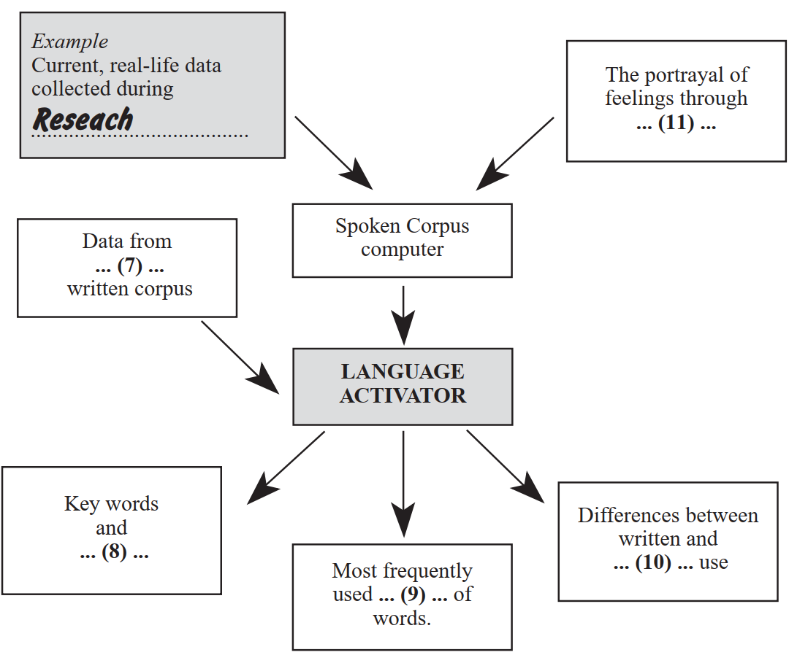

7
8
9
10
11

Question 12

Choose the appropriate letter A-D and write it in box 12 on your answer sheet.

12 Why was this article written?
A To give an example of a current dictionary
B To announce a new approach to dictionary writing
C To show how dictionaries have progressed over the years
D To compare the content of different dictionaries

READING PASSAGE 2

You should spend about 20 minutes on Questions 13-26, which are based on Reading Passage 2 below.

Moles happy as homes go underground

A
The first anybody knew about Dutchman Frank Siegmund and his family was when workmen tramping through a field found a narrow steel chimney protruding through the grass. Closer inspection revealed a chink of sky-light window among the thistles, and when amazed investigators moved down the side of the hill they came across a pine door complete with leaded diamond glass and a brass knocker set into an underground building. The Siegmunds had managed to live undetected for six years outside the border town of Breda, in Holland. They are the latest in a clutch of individualistic homemakers who have burrowed underground in search of tranquility.

B
Most, falling foul of strict building regulations, have been forced to dismantle their individualistic homes and return to more conventional lifestyles. But subterranean suburbia, Dutch-style, is about to become respectable and chic. Seven luxury homes cosseted away inside a high earth-covered noise embankment next to the main Tilburg city road recently went on the market for $296,500 each. The foundations had yet to be dug, but customers queued up to buy the unusual part-submerged houses, whose back wall consists of a grassy mound and whose front is a long glass gallery.

C
The Dutch are not the only would-be moles. Growing numbers of Europeans are burrowing below ground to create houses, offices, discos and shopping malls. It is already proving a way of life in extreme climates; in winter months in Montreal, Canada, for instance, citizens can escape the cold in an underground complex complete with shops and even health clinics. In Tokyo builders are planning a massive underground city to be begun in the next decade, and underground shopping malls are already common in Japan, where 90 percent of the population is squeezed into 20 percent of the land space.

D
Building big commercial buildings underground can be a way to avoid disfiguring or threatening a beautiful or environmentally sensitive landscape. Indeed many of the buildings which consume most land -such as cinemas, supermarkets, theatres, warehouses or libraries -have no need to be on the surface since they do not need windows.

E
There are big advantages, too, when it comes to private homes. A development of 194 houses which would take up 14 hectares of land above ground would occupy 2.7 hectares below it, while the number of roads would be halved. Under several metres of earth, noise is minimal and insulation is excellent. “We get 40 to 50 enquiries a week”, says Peter Carpenter, secretary of the British Earth Sheltering Association, which builds similar homes in Britain. “People see this as a way of building for the future.” An underground dweller himself, Carpenter has never paid a heating bill, thanks to solar panels and natural insulation.

F
In Europe the obstacle has been conservative local authorities and developers who prefer to ensure quick sales with conventional mass produced housing. But the Dutch development was greeted with undisguised relief by South Limburg planners because of Holland’s chronic shortage of land. It was the Tilburg architect Jo Hurkmans who hit on the idea of making use of noise embankments on main roads. His twofloored, four-bedroomed, two-bathroomed detached homes are now taking shape. “They are not so much below the earth as in it,” he says. “All the light will come through the glass front, which runs from the second floor ceiling to the ground. Areas which do not need much natural lighting are at the back. The living accommodation is to the front so nobody notices that the back is dark.”

G
In the US, where energy-efficient homes became popular after the oil crisis of 1973, 10,000 underground houses have been built. A terrace of five homes, Britain’s first subterranean development, is under way in Nottinghamshire. Italy’s outstanding example of subterranean architecture is the Olivetti residential centre in Ivrea. Commissioned by Roberto Olivetti in 1969, it comprises 82 one-bedroomed apartments and 12 maisonettes and forms a house/ hotel for Olivetti employees. It is built into a hill and little can be seen from outside except a glass facade. Patnzia Vallecchi, a resident since 1992, says it is little different from living in a conventional apartment.

H
Not everyone adapts so well, and in Japan scientists at the Shimizu Corporation have developed “space creation” systems which mix light, sounds, breezes and scents to stimulate people who spend long periods below ground. Underground offices in Japan are being equipped with “virtual” windows and mirrors, while underground departments in the University of Minnesota have periscopes to reflect views and light.

I
But Frank Siegmund and his family love their hobbit lifestyle. Their home evolved when he dug a cool room for his bakery business in a hill he had created. During a heatwave they took to sleeping there. “We felt at peace and so close to nature,” he says. “Gradually I began adding to the rooms. It sounds strange but we are so close to the earth we draw strength from its vibrations. Our children love it; not every child can boast of being watched through their playroom windows by rabbits.

Questions 13-20

Reading Passage 2 has nine paragraphs (A-I).

Choose the most suitable heading for each paragraph from the list of headings below.

Write the appropriate numbers (i-xii) in boxes 13 20 on your answer sheet.

Paragraph A has been done for you as an example.

NB There are more headings than paragraphs so you will not use all of them.

List of Headings

i A designer describes his houses
ii Most people prefer conventional housing
iii Simulating a natural environment
iv How an underground family home developed
v Demands on space and energy are reduced
vi The plans for future homes
vii Worldwide examples of underground living accommodation
viii Some buildings do not require natural light
ix Developing underground services around the world
x Underground living improves health
xi Homes sold before completion
xii An underground home is discovered

Example Answer
Paragraph B xii

13 Paragraph B
14 Paragraph C
15 Paragraph D
16 Paragraph E
17 Paragraph F
18 Paragraph G
19 Paragraph H
20 Paragraph I

Questions 21-26

Complete the sentences below after reading the passage.

Use NO MORE THAN THREE WORDS for each answer.

Write your answers in boxes 21-26 on your answer sheet.

21 Many developers prefer mass-produced houses because they …
22 The Dutch development was welcomed by …
23 Hurkmans’ houses are built into …
24 The Ivrea centre was developed for …
25 Japanese scientists are helping people … underground life.
26 Frank Siegmund’s first underground room was used for …

READING PASSAGE 3

You should spend about 20 minutes on Questions 27-40, which are based on Reading Passage 3 below.

A Workaholic Economy

FOR THE first century or so of the industrial revolution, increased productivity led to decreases in working hours. Employees who had been putting in 12-hour days, six days a week, found their time on the job shrinking to 10 hours daily, then, finally, to eight hours, five days a week. Only a generation ago social planners worried about what people would do with all this new-found free time. In the US, at least, it seems they need not have bothered.

Although the output per hour of work has more than doubled since 1945, leisure seems reserved largely for the unemployed and underemployed. Those who work full-time spend as much time on the job as they did at the end of World War II. In fact, working hours have increased noticeably since 1970 — perhaps because real wages have stagnated since that year. Bookstores now abound with manuals describing how to manage time and cope with stress.

There are several reasons for lost leisure. Since 1979, companies have responded to improvements in the business climate by having employees work overtime rather than by hiring extra personnel, says economist Juliet B. Schor of Harvard University. Indeed, the current economic recovery has gained a certain amount of notoriety for its “jobless” nature: increased production has been almost entirely decoupled from employment. Some firms are even downsizing as their profits climb. “All things being equal, we’d be better off spreading around the work,’ observes labour economist Ronald G. Ehrenberg of Cornell University.

Yet a host of factors pushes employers to hire fewer workers for more hours and, at the same time, compels workers to spend more time on the job. Most of those incentives involve what Ehrenberg calls the structure of compensation: quirks in the way salaries and benefits are organised that make it more profitable to ask 40 employees to labour an extra hour each than to hire one more worker to do the same 40-hour job.

Professional and managerial employees supply the most obvious lesson along these lines. Once people are on salary, their cost to a firm is the same whether they spend 35 hours a week in the office or 70. Diminishing returns may eventually set in as overworked employees lose efficiency or leave for more arable pastures. But in the short run, the employer’s incentive is clear.

Even hourly employees receive benefits - such as pension contributions and medical insurance - that are not tied to the number of hours they work. Therefore, it is more profitable for employers to work their existing employees harder.

For all that employees complain about long hours, they, too, have reasons not to trade money for leisure. “People who work reduced hours pay a huge penalty in career terms,” Schor maintains. It’s taken as a negative signal about their commitment to the firm.’ [Lotte] Bailyn [of Massachusetts Institute of Technology] adds that many corporate managers find it difficult to measure the contribution of their underlings to a firm’s well-being, so they use the number of hours worked as a proxy for output. “Employees know this,” she says, and they adjust their behavior accordingly.

“Although the image of the good worker is the one whose life belongs to the company,” Bailyn says, “it doesn’t fit the facts.’ She cites both quantitative and qualitative studies that show increased productivity for part-time workers: they make better use of the time they have, and they are less likely to succumb to fatigue in stressful jobs. Companies that employ more workers for less time also gain from the resulting redundancy, she asserts. “The extra people can cover the contingencies that you know are going to happen, such as when crises take people away from the workplace.’ Positive experiences with reduced hours have begun to change the more-is-better culture at some companies, Schor reports.

Larger firms, in particular, appear to be more willing to experiment with flexible working arrangements…

It may take even more than changes in the financial and cultural structures of employment for workers successfully to trade increased productivity and money for leisure time, Schor contends. She says the U.S. market for goods has become skewed by the assumption of full-time, two-career households. Automobile makers no longer manufacture cheap models, and developers do not build the tiny bungalows that served the first postwar generation of home buyers. Not even the humblest household object is made without a microprocessor. As Schor notes, the situation is a curious inversion of the “appropriate technology” vision that designers have had for developing countries: U.S. goods are appropriate only for high incomes and long hours.

Questions 27-32

Do the following statements agree with the views of the writer in Reading Passage 3?

In boxes 27-32, write

YES if the statement agrees with the views of the writer
NO if the statement contradicts the views of the writer
NOT GIVEN if it is impossible to say what the writer thinks about this

27 Today, employees are facing a reduction in working hours.
28 Social planners have been consulted about US employment figures.
29 Salaries have not risen significantly since the 1970s.
30 The economic recovery created more jobs.
31 Bailyn’s research shows that part-time employees work more efficiently.
32 Increased leisure time would benefit two-career households.

Questions 33-34

Choose the appropriate letters A-D and write them in boxes 33 and 34 on your answer sheet.

33 Bailyn argues that it is better for a company to employ more workers because
A it is easy to make excess staff redundant.
B crises occur if you are under-staffed.
C people are available to substitute for absent staff.
D they can project a positive image at work.

34 Schor thinks it will be difficult for workers in the US to reduce their working hours because
A they would not be able to afford cars or homes.
B employers are offering high incomes for long hours.
C the future is dependent on technological advances.
D they do not wish to return to the humble post-war era.

Questions 35-38

The writer mentions a number of factors that have resulted, in employees working longer hours.

Which FOUR of the following factors are mentioned?

Write your answers (A-H) in boxes 35-38 on your answer sheet.

List of Factors

A Books are available to help employees cope with stress.
B Extra work is offered to existing employees.
C Increased production has led to joblessness.
D Benefits and hours spent on the job are not linked.
E Overworked employees require longer to do their work.
F Longer hours indicate greater commitment to the firm.
G Managers estimate staff productivity in terms of hours worked.
H Employees value a career more than a family.

Questions 39-40

Complete the sentences below with words from the reading passage.

Write NO MORE THAN ONE WORD.

39 Returns from overburdened employees decreases with time because they lose……..
40 Employees give more work to their existing employees because for them it is……….

=================================================================

Cambridge 01 Academic Reading Test 03

Answers

1. vi
2. ii
3. x
4. viii
5. iv
6. ix
7. existing
8. (related) phrases
9. meaning/ forms
10. spoken/ oral
11. noise and pauses
12. B
13. xi
14. ix
15. viii
16. v
17. i
18. vii
19. iii
20. iv
21. sell quickly
22. planners
23. embankments
24. Olivetti employees
25. adapt to
26. a cool room
27. no
28. not given
29. yes
30. no
31. yes
32. not given
33. C
34. A
35. B
36. D
37. F
38. G
39. efficiency
40. profitable

=================================================================

Cam 01 Academic Reading Test 04

READING PASSAGE 1

You should spend about 20 minutes on Questions 1-13, which are based on Reading Passage 1 below.

GLASS
Capturing The Dance of Light

A
Glass, in one form or another, has long been in noble service to humans. As one of the most widely used of manufactured materials, and certainly the most versatile, it can be as imposing as a telescope mirror the width of a tennis court or as small and simple as a marble rolling across dirt. The uses of this adaptable material have been broadened dramatically by new technologies glass fibre optics — more than eight million miles — carrying telephone and television signals across nations, glass ceramics serving as the nose cones of missiles and as crowns for teeth; tiny glass beads taking radiation doses inside the body to specific organs, even a new type of glass fashioned of nuclear waste in order to dispose of that unwanted material.

B
On the horizon are optical computers. These could store programs and process information by means of light - pulses from tiny lasers - rather than electrons and the pulses would travel over glass fibres, not copper wire. These machines could function hundreds of times faster than today’s electronic computers and hold vastly more information. Today fibre optics viruses. A new generation of optical instruments is emerging that can provide detailed imaging of the inner workings of cells. It is the surge in fibre optic use and in liquid crystal displays that has set the U.S. glass industry (a 16 billion dollar business employing some 150,000 workers) to building new plants to meet demand.

C
But it is not only in technology and commerce that glass has widened its horizons. The use of glass as art, a tradition spins back at least to Roman times, is also booming. Nearly everywhere, it seems, men and women are blowing glass and creating works of art. “I didn’t sell a piece of glass until 1975”, Dale Chihuly said, smiling, for in the 18 years since the end of the dry spell, he has become one of the most financially successful artists of the 20th century. He now has a new commission - a glass sculpture for the headquarters building of a pizza company - for which his fee is half a million dollars.

D
But not all the glass technology that touches our lives is ultra-modern. Consider the simple light bulb; at the turn of the century most light bulbs were hand blown, and the cost of one was equivalent to half a day’s pay for the average worker. In effect, the invention of the ribbon machine by Corning in the 1920s lighted a nation. The price of a bulb plunged. Small wonder that the machine has been called one of the great mechanical achievements of all time. Yet it is very simple: a narrow ribbon of molten glass travels over a moving belt of steel in which there are holes. The glass sags through the holes and into waiting moulds. Puffs of compressed air then shape the glass. In this way, the envelope of a light bulb is made by a single machine at the rate of 66,000 an hour, as compared with 1,200 a day produced by a team of four glassblowers.

E
The secret of the versatility of glass lies in its interior structure. Although it is rigid, and thus like a solid, the atoms are arranged in a random disordered fashion, characteristic of a liquid. In the melting process, the atoms in the raw materials are disturbed from their normal position in the molecular structure; before they can find their way back to crystalline arrangements the glass cools. This looseness in molecular structure gives the material what engineers call tremendous “formability” which allows technicians to tailor glass to whatever they need.

F
Today, scientists continue to experiment with new glass mixtures and building designers test their imaginations with applications of special types of glass. A London architect, Mike Davies, sees even more dramatic buildings using molecular chemistry. “Glass is the great building material of the future, the dynamic skin,’ he said. “Think of glass that has been treated to react to electric currents going through it, glass that will change from clear to opaque at the push of a button, that gives you instant curtains. Think of how the tall buildings in New York could perform a symphony of colours as the glass in them is made to change colours instantly.” Glass as instant curtains is available now, but the cost is exorbitant. As for the glass changing colours instantly, that may come true. Mike Davies’s vision may indeed be on the way to fulfilment.

Questions 1-5

Reading Passage 1 has six paragraphs (A-F).

Choose the most suitable heading/or each paragraph from the list of headings below.

Write the appropriate numbers (i-x) in boxes 1-5 on your answer sheet.

Paragraph A has been done for you as an example.

NB There are more headings than paragraphs so you will not use all of them. You may use any heading more at once.

Example Answer
Paragraph A x

List of Headings

i Growth in the market for glass crafts
ii Computers and their dependence on glass
iii What makes glass so adaptable
iv Historical development of glass
v Scientists’ dreams cost millions
vi Architectural experiments with glass
vii Glass art galleries flourish
viii Exciting innovations in fibre optics
ix A former glass technology
x Everyday uses of glass

1 Paragraph B
2 Paragraph C
3 Paragraph D
4 Paragraph E
5 Paragraph F

Questions 6-8

The diagram below shows the principle of Corning’s ribbon machine.

Label the diagram by selecting NO MORE THAN THREE WORDS from the Reading Passage to fill each numbered space.

Write your answers in boxes 6-8 on your answer sheet.

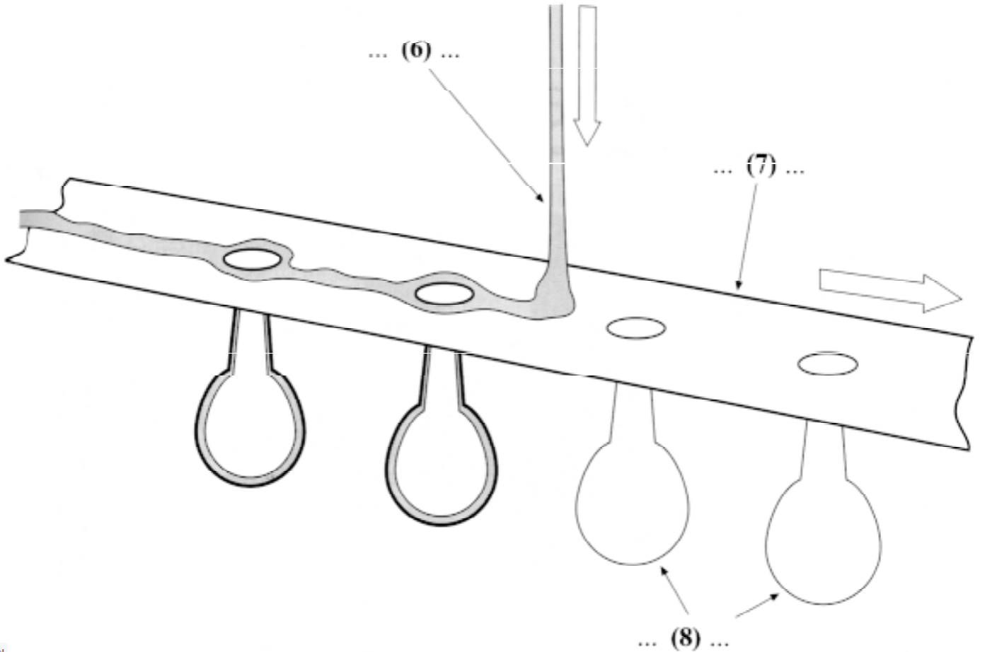

6
7
8

Questions 9-13

Look at the list below of the uses of glass.

According to the passage, state whether these uses exist today, will exist in the future or are not mentioned by the writer.

In boxes 9-13, write

A if the uses exist today
B if the uses will exist in the future
C if the uses are not mentioned by the writer

9 dental fittings
10 optical computers
11 sculptures
12 fashions
13 curtains

READING PASSAGE 2

You should spend about 20 minutes on Questions 14-27, which are based on Reading Passage 2 below.

Why some women cross the finish line ahead of men

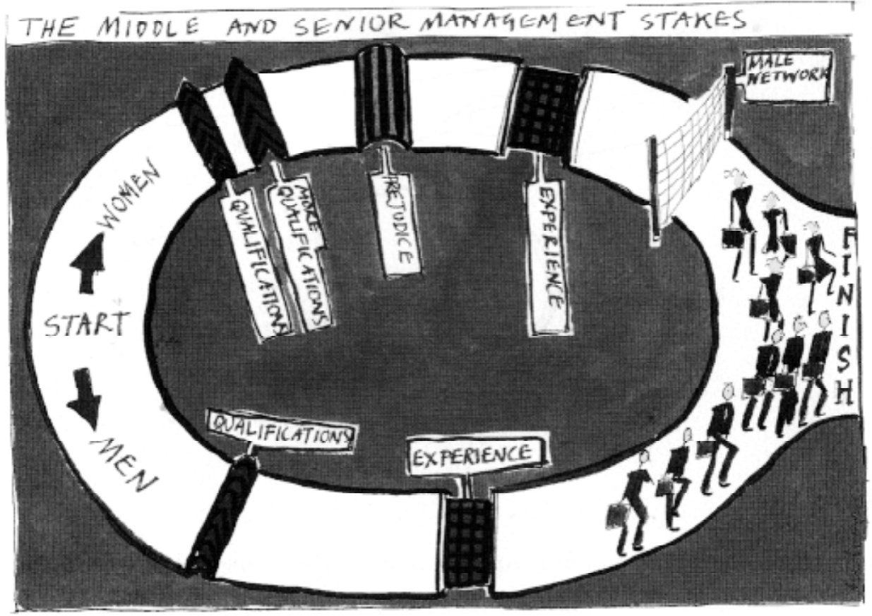

RECRUITMENT
The course is tougher but women are staying the distance, reports Andrew Crisp.

A
Women who apply for jobs in middle or senior management have a higher success rate than men, according to an employment survey. But of course far fewer of them apply for these positions. The study, by recruitment consultants NB Selection, shows that while one in six men who appear on interview shortlists get jobs, the figure rises to one in four for women.

B
The study concentrated on applications for management positions in the $45,000 to $110,000 salary range and found that women are more successful than men in both the private and public sectors Dr Elisabeth Marx from London-based NB Selection described the findings as encouraging for women, in that they send a positive message to them to apply for interesting management positions. But she added, “We should not lose sight of the fact that significantly fewer women apply for senior positions in comparison with men.”

C
Reasons for higher success rates among women are difficult to isolate. One explanation suggested is that if a woman candidate manages to get on a shortlist, then she has probably already proved herself to be an exceptional candidate. Dr Marx said that when women apply for positions they tend to be better qualified than their male counterparts but are more selective and conservative in their job search. Women tend to research thoroughly before applying for positions or attending interviews. Men, on the other hand, seem to rely on their ability to sell themselves and to convince employers that any shortcomings they have will not prevent them from doing a good job.

D
Managerial and executive progress made by women is confirmed by the annual survey of boards of directors carried out by Korn/ Ferry/ Carre/ Orban International. This year the survey shows a doubling of the number of women serving as non-executive directors compared with the previous year. However, progress remains painfully slow and there were still only 18 posts filled by women out of a total of 354 nonexecutive positions surveyed. Hilary Sears, a partner with Korn/ Ferry, said, “Women have raised the level of grades we are employed in but we have still not broken through barriers to the top.”

E
In Europe a recent feature of corporate life in the recession has been the delayering of management structures.
Sears said that this has halted progress for women in as much as de-layering has taken place either where women are working or in layers they aspire to. Sears also noted a positive trend from the recession, which has been the growing number of women who have started up on their own.

F
In business as a whole, there are a number of factors encouraging the prospect of greater equality in the workforce. Demographic trends suggest that the number of women going into employment is steadily increasing. In addition a far greater number of women are now passing through higher education, making them better qualified to move into management positions.

G
Organisations such as the European Women’s Management Development Network provide a range of opportunities for women to enhance their skills and contacts. Through a series of both pan-European and national workshops and conferences the barriers to women in employment are being broken down. However, Ariane Berthoin Antal, director of the International Institute for Organisational Change of Archamps in France, said that there is only anecdotal evidence of changes in recruitment patterns. And she said, “It’s still so hard for women to even get on to shortlists -there are so many hurdles and barriers.” Antal agreed that there have been some positive signs but said “Until there is a belief among employers, until they value the difference, nothing will change.”

Questions 14-19

Reading Passage 2 has 7 paragraphs (A-G).

State which paragraph discusses each of the points below.

Write the appropriate letter (A-G) in boxes 14-19 on your answer sheet.

Example Answer
The salary range studied in the NB Selection survey. B

14 The drawbacks of current company restructuring patterns.
15 Associations that provide support for professional women.
16 The success rate of female job applicants for management positions.
17 Male and female approaches to job applications.
18 Reasons why more women are being employed in the business sector.
19 The improvement in female numbers on company management structures.

Questions 20-23

The author makes reference to three consultants in the Reading Passage.

Which of the list of points below do these consultants make?

In boxes 20-23, write

M if the point is made by Dr Marx
S if the point is made by Hilary Sears
A if the point is made by Ariane Berthoin Antal

20 Selection procedures do not favour women.
21 The number of female-run businesses is increasing.
22 Male applicants exceed female applicants for top posts.
23 Women hold higher positions now than they used to.

Questions 24-27

Using NO MORE THAN THREE WORDS answer the following questions.

Write your answers in boxes 24-27 on your answer sheet.

24 What change has there been in the number of women in top management positions detailed in the annual survey?
25 What aspect of company structuring has disadvantaged women?
26 What information tells us that more women are working nowadays?
27 Which group of people should change their attitude to recruitment?

READING PASSAGE 3

You should spend about 20 minutes on Questions 28-40, which are based on Reading Passage 3 below.

Population viability analysis

Part A
To make political decisions about the extent and type of forestry in a region it is important to understand the consequences of those decisions. One tool for assessing the impact of forestry on the ecosystem is population viability analysis (PVA). This is a tool for predicting the probability that a species will become extinct in a particular region over a specific period. It has been successfully used in the United States to provide input into resource exploitation decisions and assist wildlife managers and there is now enormous potential for using population viability to assist wildlife management in Australia’s forests.

A species becomes extinct when the last individual dies. This observation is a useful starting point for any discussion of extinction as it highlights the role of luck and chance in the extinction process. To make a prediction about extinction we need to understand the processes that can contribute to it and these fall into four broad categories which are discussed below.

Part B
A
Early attempts to predict population viability were based on demographic uncertainty Whether an individual survives from one year to the next will largely be a matter of chance. Some pairs may produce several young in a single year while others may produce none in that same year. Small populations will fluctuate enormously because of the random nature of birth and death and these chance fluctuations can cause species extinctions even if, on average, the population size should increase. Taking only this uncertainty of ability to reproduce into account, extinction is unlikely if the number of individuals in a population is above about 50 and the population is growing.

B
Small populations cannot avoid a certain amount of inbreeding. This is particularly true if there is a very small number of one sex. For example, if there are only 20 individuals of a species and only one is a male, all future individuals in the species must be descended from that one male. For most animal species such individuals are less likely to survive and reproduce. Inbreeding increases the chance of extinction.

C
Variation within a species is the raw material upon which natural selection acts. Without genetic variability a species lacks the capacity to evolve and cannot adapt to changes in its environment or to new predators and new diseases. The loss of genetic diversity associated with reductions in population size will contribute to the likelihood of extinction.

D
Recent research has shown that other factors need to be considered. Australia’s environment fluctuates enormously from year to year. These fluctuations add yet another degree of uncertainty to the survival of many species. Catastrophes such as fire, flood, drought or epidemic may reduce population sizes to a small fraction of their average level. When allowance is made for these two additional elements of uncertainty the population size necessary to be confident of persistence for a few hundred years may increase to several thousand.

Part C
Beside these processes we need to bear in mind the distribution of a population. A species that occurs in five isolated places each containing 20 individuals will not have the same probability of extinction as a species with a single population of 100 individuals in a single locality.

Where logging occurs (that is, the cutting down of forests for timber) forest dependent creatures in that area will be forced to leave. Ground-dwelling herbivores may return within a decade. However, arboreal marsupials (that is animals which live in trees) may not recover to pre-logging densities for over a century. As more forests are logged, animal population sizes will be reduced further. Regardless of the theory or model that we choose, a reduction in population size decreases the genetic diversity of a population and increases the probability of extinction because of any or all of the processes listed above. It is therefore a scientific fact that increasing the area that is loaded in any region will increase the probability that forest-dependent animals will become extinct.

Questions 28-31

Do the following statements agree with the views of the writer in Part A of Reading Passage 3?

In boxes 28-31 on your answer sheet, write

YES if the statement agrees with the writer
NO if the statement contradicts the writer
NOT GIVEN if it is impossible to say what the writer thinks about this

28 Scientists are interested in the effect of forestry on native animals.
29 PVA has been used in Australia for many years.
30 A species is said to be extinct when only one individual exists.
31 Extinction is a naturally occurring phenomenon.

Questions 32-35

These questions are based on Part B of Reading Passage 3.

In paragraphs A to D the author describes four processes which may contribute to the extinction of a species.

Match the list of processes (i-vi) to the paragraphs.

Write the appropriate number (i-vi) in boxes 32-35 on your answer sheet.

NB There are more processes than paragraphs so you will not use all of them.

32 Paragraph A  33 Paragraph B  34 Paragraph C  35 Paragraph D | Processes  i Loss of ability to adapt  ii Natural disasters  iii An imbalance of the sexes  iv Human disasters  v Evolution  vi The haphazard nature of reproduction

Questions 36-39

Based on your reading of Part C, complete the sentences below with words taken from the passage.

Use NO MORE THAN THREE WORDS for each answer.

Write your answers in boxes 36-38 on your answer sheet.

While the population of a species may be on the increase, there is always a chance that small isolated groups 36……………………….
Survival of a species depends on a balance between the size of a population and its 37…………………….
The likelihood that animals which live in forests will become extinct is increased when 38……………………
After logging herbivores that reside on ground find it easier to return as compared to 39………………

Question 40

Choose the appropriate letter A-D and write it in box 39 on your answer sheet.

40 An alternative heading for the passage could be:
A The protection of native flora and fauna
B Influential factors in assessing survival probability
C An economic rationale for the logging of forests
D Preventive measures for the extinction of a species

=================================================================

Cambridge 01 Academic Reading Test 04

Answers

1. viii
2. i
3. ix
4. iii
5. vi
6. molten glass
7. steel belt
8. (lightbulb) moulds
9. A
10. B
11. A
12. C
13. A
14. E
15. G
16. A
17. C
18. F
19. D
20. A
21. S
22. M
23. S
24. double
25. de-layering
26. demographic trends
27. employers
28. not given
29. no
30. no
31. not given
32. vi
33. iii
34. i
35. ii
36. may not survive
37. locality/ distribution
38. logging occurs
39. arboreal marsupials
40. B

=================================================================

